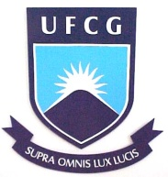 | Universidade Federal de Campina Grande  Centro de Ciências e Tecnologia  Coordenação do Programa de Pós-Graduação em Matemática
CICLO DE CONFERÊNCIAS DA UAMat

Título: “Stable and Parabolic Hypersurfaces in Lorentzian Spacetimes”

Palestrante: Eraldo Almeida Lima Júnior
Resumo: In this presentation, we deal with parabolic stable spacelike hypersurfaces with constant mean curvature immersed in a Lorentzian product. In this setting, we use some cut-off functions directly related to the parabolicity. We obtained rigidity properties for stable hypersurfaces, such as constant angle with the vertical direction timelike parallel direction $\partial_t$, maximality and Calabi-Bernstein results in this process we also observed that such hypersurfaces must have zero Gauss-Kronecker curvature. We also attained to the case of surfaces where we can consider classic results as well obtain more refined theorems than in the general case.

Data: 04 de maio de 2017
Local: Auditório da Unidade Acadêmica de Matemática.
Horário: 10:00 h.

